**Lab Exercise 6: Sampling, FFTs, IFFTs, & Spectral Analysis**

# Part 1: Continuous and Discrete Fourier Transforms

## Part A: Figure Plotted of Signal f(t) over 9 seconds

## 

*Figure 1: f(t) plotted over 9 seconds*

## Part B: Continuous Fourier Transforms and Discrete Fourier Transforms

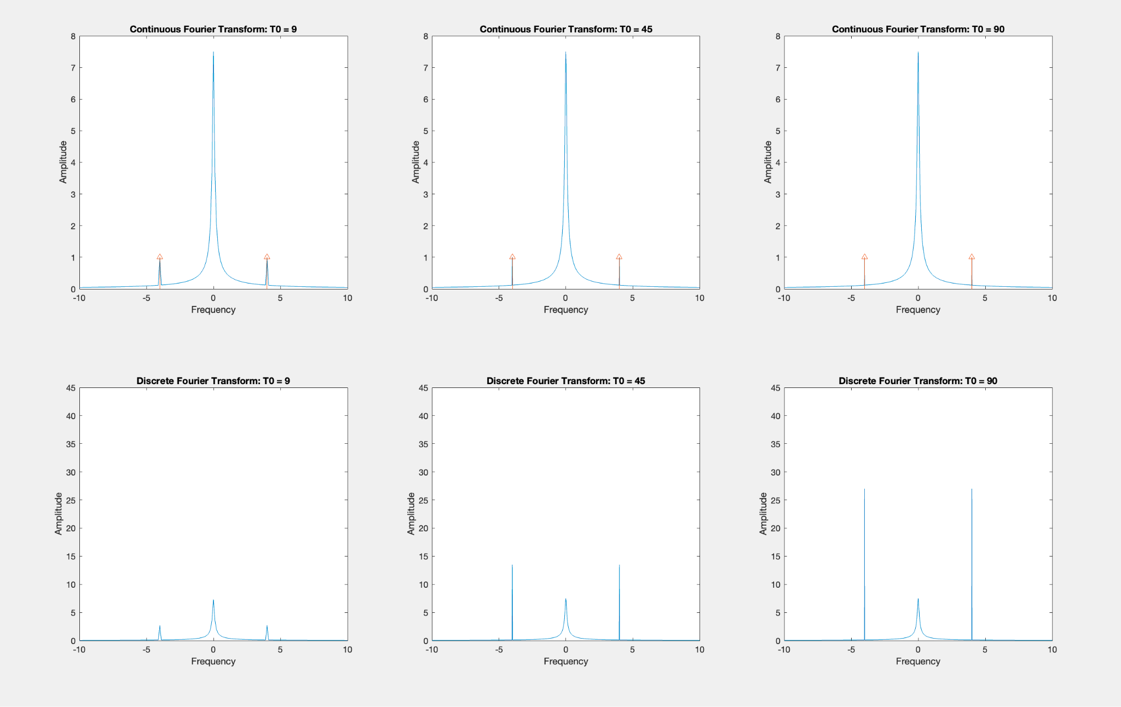

*Figure 2: Continuous and Discrete Fourier Transforms at different T0 values*

## Part C Analysis

### 1.C.1 Qualitatively, does the DFT correspond well with the corresponding theoretical continuous

### Fourier transforms?

Yes, qualitatively the Discrete Fourier Transform corresponds significantly well with the plotted theoretical continuous Fourier Transforms. However, it does stray away from this observation as on the DFT plots the impulses from the continuous Fourier transforms become non-instantaneous spikes in amplitude at both x = 4 Hz and x = -4 Hz. The amplitude of these spikes varies among the DFTs.

### 1.C.2.A There are two components in your plots: a peak that does not change in amplitude and peaks

### that do change in amplitude with increasing T0. Which part of f(t) produces each part of your plots?

### The exponential component of f(t), 3e-0.4tu(t), creates the peak visible at x = 0 Hz, which retains an amplitude of around 7.5 regardless of the changes in T0. However, the sinusoidal component of the function f(t), , creates impulse responses at x = 4 Hz and -4 Hz. The impulses get smaller and sharper as T0 increases due to the increasing resolution, which allows each successive DFT to more closely approximate the infinitely small, infinitely tall nature of the impulse response.

### 1.C.2.B What is the mathematical relationship between the amplitude of the Fourier transform

### (or FFT) and the exponential component of f(t)?

### 

Mathematically, the magnitude of the peak can be determined by the coefficient that is associated with the exponential component of the function f(t). The exact calculation can be found by dividing the leading coefficient that is outside the exponential by the coefficient of the exponential. The Fourier Transform of the exponential component of the function is shown below.

### 1.C.2.C What is the mathematical relationship between the amplitude of the of the FFT and the

### sine wave component of f(t)?

The coefficient of the sin wave element is what helps calculate and determine the different amplitudes of the peaks. There is a direct correlation between the increase of the coefficient and the amplitudes. If the coefficient increases, the amplitudes of the impulses increase and if the coefficient decreases, the amplitude decreases along with it. Moreover, the coefficient that is inside the sin wave, in this case it would be 8, determines where on the x-axis the impulses and peaks will appear in the frequency spectrum graph. The frequency spectrum graphs have a pulse width of 8 meaning that the impulses are at x= -4 Hz and x= 4 Hz. Therefore, if the coefficient were to increase, then the pulse width would also increase meaning that the impulses would occur further from the origin. Likewise, if the coefficient were to decrease, it would result in impulses that are closer to the origin.

# Part 2: PRACTICAL APPLICATION : EEG PROCESSING

Table 1: Reference Table from Lab Instructions

| EEG Wave Name | Frequency Range |
| --- | --- |
|  | 0.5-2 |
|  | 4-7 |
|  | 8-15 |
|  | 16-31 |
|  | 32-100 |

## Part A: Analyze the Signal

### 

### 2.1.Provide all plots that you think help with your analysis. Discuss the underlying frequencies in the signal. Discuss when there are transitions in frequencies. Do you see all wave types? Are there any frequencies that are continuous? Over what times do you observe what frequencies? Do you observe any noise? If so, what type(s) of noise do you see, and when? You may find it useful to create a table (see below).

|  |
| --- |
| *Fig. 3: The time domain plot of the EEG data, a 15 minute signal sampled at 2kHz. The signal has spikes in amplitude that correspond to the actual signal, which is highly obfuscated in the time domain.* |

|  |
| --- |
| *Fig. 4: The Discrete Fourier Transform of the data, broken up into a subplot of the frequencies present in each minute of the EEG signal.* |

|  |
| --- |
| *Fig. 5: The spectrogram of the EEG data, providing a more visual and complete view of the frequencies that appear in the data over time.* |

The EEG signal contains all of the types of EEG waves, as well as two types of noise. The signal first starts with 60Hz noise that continues throughout the whole signal, along with an 8Hz type wave that lasts for 19.2 seconds, after which there is a pause of 113.4 seconds. Another signal begins 132.6 seconds in, which is a 2Hz wave that lasts for 46.2 seconds. A short pause of 7.8 seconds is followed by a 87Hz wave that lasts for 42.6 seconds, and then another 107.4 second pause happens before a 4Hz wave that lasts for 66.6 seconds. After another 132.6 seconds, a 15Hz wave happens that lasts for only 9 seconds, before another 102.6 second pause. Another noise signal then comes in, which is a harmonic group of signals from 0 to 100Hz that are spaced 5Hz apart from each other, which lasts for 144 seconds. While this noise is happening, at 702.6 seconds a 40Hz signal happens that lasts for 117 seconds. This information is summarized in Table 1.

Table 2: The start time, stop time, calculated duration, approximate frequency, and wave type of all waveforms present in the EEG signal. All times and frequencies are approximate.

| **Start Time (sec)** | **Stop Time (sec)** | **Duration (sec)** | **Approx. Frequency (Hz)** | **Wave Type** |
| --- | --- | --- | --- | --- |
| 0 | 19.2 | 19.2 | 8 |  |
| 132.6 | 178.8 | 46.2 | 2 |  |
| 186.6 | 229.2 | 42.6 | 87 |  |
| 336.6 | 403.2 | 66.6 | 4 |  |
| 535.8 | 544.8 | 9.0 | 15 |  |
| 702.6 | 846.6 | 144.0 | 40 |  |
| 647.4 | 764.4 | 117.0 | (5, 10, 15, …, 100) | Non-Descript Noise |
| 0 | 900 | 900 | 60 | 60 Hz Noise |

### 

### 

### 

### 

## Part B: Finding the Dreaming States

### 2.2: Dream states are associated with lower amplitude and higher frequency

### EEG signals. Assume that EEGs over 75 Hz correspond to when your patient is dreaming. How many dreams did your patient have? When did it/they occur? How long did it/they last?

### The patient had one dream, which was an 87Hz signal that occurred 186.6 seconds in and lasted for 46.2 seconds.

## Part C: Noise

### 2.3.1 : Discuss the noise in the system. When does noise occur? What types of noise do you see? Does the noise interfere with any of the signals in the EEG? If so, when and why? If not, why not? Do the

### results shown in your graphs make sense with respect to each other? Be as complete as possible in your

### answer.

### 

There are two types of noise in the signal. The first is a 60Hz signal that lasts from the start to the end of the EEG signal, and the second is a harmonic set of signals from 0 to 100Hz that are 5Hz apart from each other. The noise signals interfere significantly with the signals in the time domain, as the amplitudes of each overlap. It is only possible to tell where a signal is in the time domain through the increases in amplitude compared to the “baseline” set by the 60Hz noise, and even this inference of data is interfered with in the case of the 40Hz signal, which has parts of it overlapped with the harmonic noise. However, for the frequency domain based graphs, the noise does not interfere significantly, as it is easy to tell apart the signals from each other based on their frequency. This is especially true for the spectrogram, where the strength of the signals corresponds to the darkness of the band representing them; the true signals thus show up darker than both of the noises, and in the case of the 40Hz signal and the harmonic noise where they overlap, the 40Hz signal is clearly visible against the noise.

All three of the graphs make sense with respect to each other. Larger amplitudes in the time domain correspond to the size of the sum of the signal amplitudes in the fourier transform graphs, the fourier transform frequencies that have large amplitudes have matching visible spectrogram bars, and the larger amplitudes in the time domain correspond to periods of time in which there were two or more spectrogram bars, which was when there was a signal or additional noise (or both) on top of the background 60Hz noise.

| **Revision** | **Description** | **Date** |
| --- | --- | --- |
| A | Original Document | 11/11/2023 |
|  |  |  |